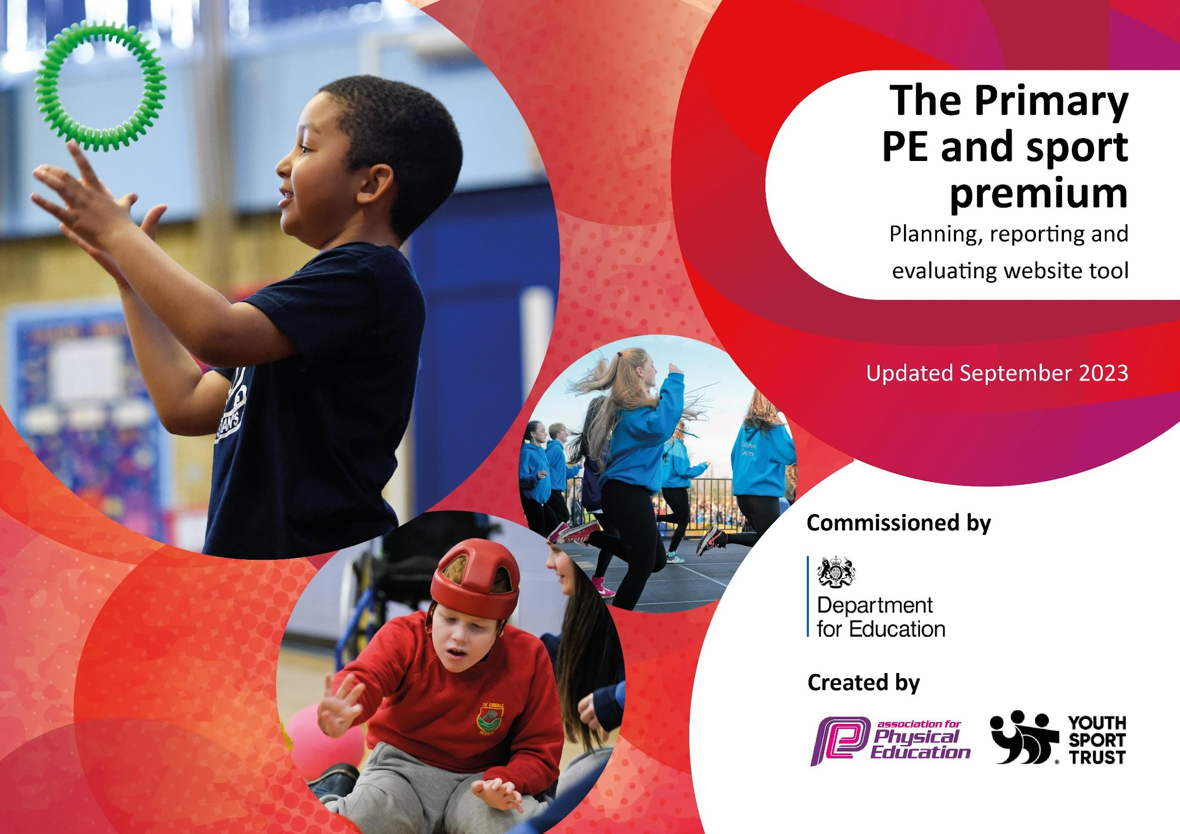


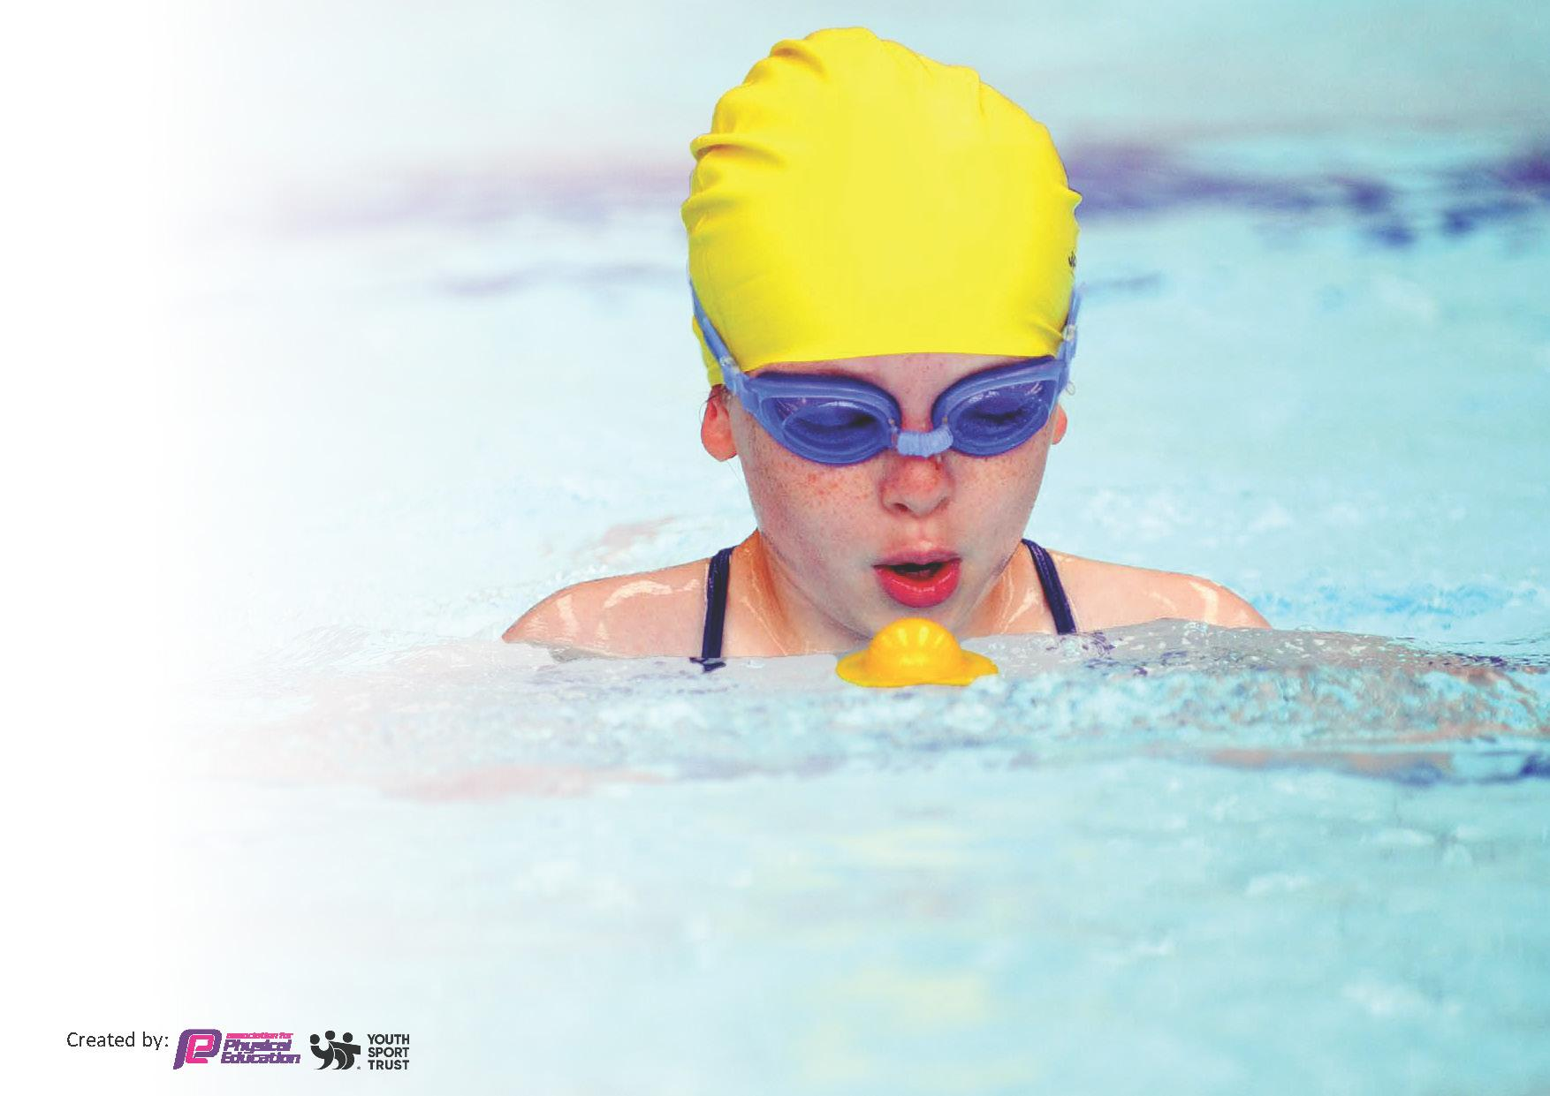
This template can be used for multiple purposes:
by:
- It enables schools to effectively plan their use of the Primary PE and sport premium
- It helps schools to meet the requirements (as set out in guidance) to publish information on their Primary PE and sport premium
- It will be an effective document to support Ofsted inspections enabling schools to evidence progress in Physical Education (PE) and evidence swimming attainment, which forms part of the PE National Curriculum. We would recommend schools consider
the Intent, Implementation and Impact of any spend, as examined within the Education Inspection Framework.

It is important that your grant is used effectively and based on school need.

Schools must use the funding to make additional and sustainable
improvements to the quality of the PE, School Sport and Physical Activity (PESSPA)
they offer. This means that you should use the Primary PE and sport premium to:

- Build capacity and capability within the school to ensure that improvements made now will benefit pupils joining the school in future years
- Develop or add to the PESSPA activities that your school already offers.

The Primary PE and sport premium should not be used to fund capital spend projects; the school’s core budget should fund these. Further detail on capital expenditure can be found in the updated Primary PE and sport premium guidance.

The Primary PE and sport premium guidance, outlines 5 key priorities that funding should be used towards. It is not necessary that spending has to meet all the key priorities, you should select the priorities that you aim to use any funding towards.

Although completing this template is not a requirement for schools, schools are required to publish details of how they spend this funding. Schools must also outline what the impact this funding has had on pupils’ PE and sport participation and attainment and how any spending will be sustainable in the future. All funding must be spent by 31st July 2025.

The Department for Education has worked closely with the Association for Physical Education (afPE) and the Youth Sport Trust (YST) to develop this template and encourages schools to use it. This template is an effective way of meeting the reporting requirements of the
Primary PE and sport premium.

Review of last year’s spend and key achievements (2023/2024)

We recommend you start by reflecting on the impact of current provision and reviewing your previous spend.

Activity/Action | Impact | Comments
- Consolidating the implementation of Complete PE to support the implementation of a high quality Physical Education Curriculum which develops progressive planning to support every child’s learning.  - Children across the school have competed in a range of sporting events this year across Witney and beyond. These have included inter school competitions in: football, netball, cross country, boccia, sports hall athletics and ultra-Olympics.  - We have now started to provide timetabled Forest school provision on site.  - Children in Year 4 continue be offered swimming lessons at Windrush Leisure Centre. | - Increased staff confidence/competence in teaching PE due to new Complete PE scheme. Children are engaged in and enjoy PE lessons.  - Children given wide range of opportunities to compete in inter-school competitive sport.  - Forest school provision in place to keep children active for 30 minutes per day (minimum).  - Provision designed to equip children to swim competently, confidently and proficiently over a distance of at least 25 metres using a range of strokes effectively and perform safe self-rescue in different water-based situations. | Total funding for 2023/24: £18000  Total funding spent for 2023/24: £17840  Total funding carried over into 2024/2025: £60

Key priorities and Planning
This planning template will allow schools to accurately plan their spending.

Action – what are you planning to do | Who does this action impact? | Key indicator to meet | Impacts and how sustainability will be achieved? | Cost linked to the action
1.To provide all pupils with play  opportunities to ensure they are undertaking a minimum of 30 minutes of physical activity a day.  2.A varied programme of after school sports clubs is offered to children throughout the academic year.  3. To develop a progressive, broad and balanced PE curriculum supported by an extra-curricular programme that allows children to develop skills, knowledge and confidence.  4. To work with Witney Partnership member schools to develop inter competitions for our children. | Lunchtime supervisors / teaching staff, coaches - as they need to lead the activity  Pupils – as they will take part.  External Sports Coaches as they lead the sessions  Pupils – as they will take part  Primary generalist teachers  Children taking part in inter-school schools tournaments & staff accompanying children to tournaments. | Key indicator 2 -The engagement of all pupils in regular physical activity – the Chief Medical Officer guidelines recommend that all children and young people aged 5 to 18 engage in at least 60 minutes of physical activity per day, of which 30 minutes should be in school.  Key indicator 3: The profile of PE and sport is raised across the school as a tool for whole-school improvement  Key indicator 4: Broader experience of a range of sports and activities offered to all pupils.  Key Indicator 1: Increased confidence, knowledge, and skills of all staff in teaching PE and sport.  Key indicator 5: Increased participation in competitive sport. | More pupils meeting their daily physical activity goal, more pupils encouraged to take part in PE and Sport Activities.  More children taking part in organized sports outside of curricular provision.  Primary teachers more confident to deliver effective PE (through our subscription to Complete PE scheme of work) supporting pupils to undertake extra activities inside and outside of school, including teaching water safety and swimming and as a result improved % of pupil’s attainment in PE.  Children across both Key Stages given the chance to represent the school in competitive inter-school sports competitions. | £843.06  £1935  £8,261  £2,061

Key achievements 2024-2025
This template will be completed at the end of the academic year and will showcase the key achievements schools have made with their Primary PE and sport premium spending.

Activity/Action | Impact | Comments
- In 2024/2025 OLOL gained a Gold Award in the School Games mark. This externally validated, government led award scheme celebrates our commitment to developing competitive sport within our school and community.  - Year 5 Play Leaders completed mentoring training with Sam Hook from the Witney Sports Partnership. This was to equip them to set up, run and monitor structured play activities for the rest of the school at break and lunch times.  - In collaboration with the Tim Henman foundation, we were able to provide weekly tennis sessions for disadvantaged children, focusing on those with special educational needs & disabilities and children from low-income backgrounds.  - Promoting Girls' football - this year entered a team into a U11 Girls’ football league  - Twice a week children took part in high quality PE lessons. Lessons were planned and delivered according to the Complete PE scheme of work, with clear links to the objectives contained with the NC.  - All Year 3/4 children were offered swimming lessons as part of the NC.  - A varied programme of after school sports clubs have been offered to children throughout the academic year. These provided children of all ages and backgrounds the opportunity to participate in organised sport.  - Children from across KS1 and KS2 represented OLOL in various inter school sports tournaments throughout the year such as: football (girls and boys), cross country, netball, athletics, boccia etc.  - Children have had access to a range of different sports and play equipment to ensure that they remained active in both play times and lunch times. Playtimes provided the opportunity to access additional active play resources which were used both independently and collaboratively under supervision of lunchtime staff.  - Outdoor playground floor marking has been used to promote outdoor physical activity (running lanes, netball/basketball court markings etc)  - Write ups/photos of inter school sports competitions (Boys’ U11 football league, Witney Partnership Cross Country and National Cup U11 Girls Football Tournament) was included in monthly newsletters sent to parents  - School Sports teams were celebrated in assemblies with mini reports given by PE coordinator on inter school matches to the rest of the school.  - Extra-curricular sports clubs on offer were advertised to parents via Parent mail and the school website.  - Sports Day was a big success with children from EYFS to Year 6 competing in a range of running, throwing, jumping and skipping events. | The award demonstrates that we provide equal opportunities for all young people, regardless of gender and understand and develop our approach to physical literacy.  Children given increased opportunities to take part in at least 30 minutes of exercise in school per day (in addition to our curriculum offer).  Through our work with the foundation we have been able to provide organized, extra-curricular sport to SEN and disadvantaged children in a way which is adapted to their particular need.  More girls than ever have now represented the school in competitive football. Over 20 girls played for the school team this year.  High quality PE lessons were delivered by teaching staff to children across the school from EYFS up to Year 6 which show a clear progression and build upon prior learning to support and challenge children within a range of abilities.  Greater percentage of children meeting National Curriculum requirements for swimming and water safety.  Children given increased opportunities to take part in a greater variety of organised and competitive sports outside of existing curriculum offer.  Approximately 25% of the total number of children on roll represented the school in inter school sport last year.  Children given increased opportunities to take part in at least 30 minutes of exercise in school per day (in addition to our curriculum offer).  Children given increased opportunities to take part in at least 30 minutes of exercise in school per day (in addition to our curriculum offer).  Profile of PE and sport at OLOL raised.  Profile of PE and sport at OLOL raised.  Children given increased opportunities to take part in a greater variety of organised and competitive sports outside of existing curriculum offer.  The profile of PE raised and used as a tool for whole school improvement. Parents/govenors/other stakeholders aware of how important sport is at OLOL. | To maintain this, we will need to enter more B and C teams in Witney Partnership events.  The monitoring of this has been inconsistent. The children were very receptive to the play leaders initially but after a while the novelty wore off. We will need to re-visit this next year to raise the profile of Play Leaders again.  The partnership with THF has been renewed and we will continue to provide extra-curricular sports provision from disadvantaged and SEN children for the 25/26 academic year.  We hope to expand the age range of girls playing inter-school football next year into U8/9.  Next year, we’d like to allocate more funding for specialist sports coaches to further develop staff teaching pedagogy.  Next year we will continue our membership of the Witney Partnership and take part more School Games events to further develop inter-school sport at OLOL/

Swimming Data
Meeting National Curriculum requirements for swimming and water safety.
Priority should always be given to ensuring that pupils can perform safe self-rescue even if they do not fully meet the first two requirements of the National Curriculum programme of study

Question | Stats: | Further context  Relative to local challenges
What percentage of your current Year 6 cohort can swim competently, confidently and proficiently over a distance of at least 25 metres? | 13/28: 46% | We have levels of transition amongst our Year 6 cohort- a high percentage of children in Year 6 were not with us in Year 4 when curricular swimming lessons were offered which has impacted on the percentage of confident swimmers in Year 6.
What percentage of your current Year 6 cohort can use a range of strokes effectively [for example, front crawl, backstroke, and breaststroke]? | 13/28: 46% | N/A

What percentage of your current Year 6 cohort are able to perform safe self-rescue in different water-based situations? |  | N/A
If your schools swimming data is below national expectation, you can choose to use the Primary PE and sport premium to provide additional top-up sessions for those pupils that did not meet National Curriculum  requirements after the completion of core lessons. Have you done this? | No | N/A
Have you provided CPD to improve the knowledge and confidence of staff to be able to teach swimming and water safety? | No

Signed off by:

Head Teacher: | (Name)
Subject Leader or the individual responsible for the Primary PE and sport premium: | Joe Cooper Year 6 Teacher/PE Lead
Governor: | (Name and Role)
Date: | 16.09.25

