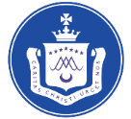
Our Lady of Lourdes Catholic Primary School
French (KS2) – Annual overview

 | Autumn |  | Spring |  | Summer
Year 3 | I am learning French | Animals | Instruments | I am able to | Fruits / Vegetables | Ice creams
Year 4 | Seasons | Vegetables | Presenting myself | My family | In the classroom | At the tea room
Year 5 | My family | The date | Do you have a pet? | Habitats | Olympics | Weather
Year 6 | The date | Do you have a pet? | Clothes | At school | At the weekend | World War 2

